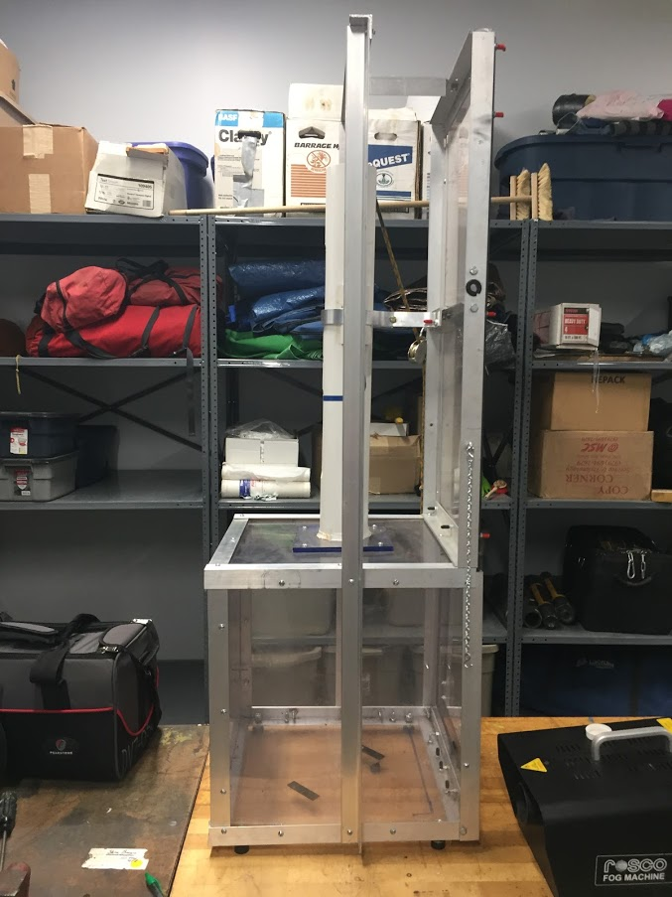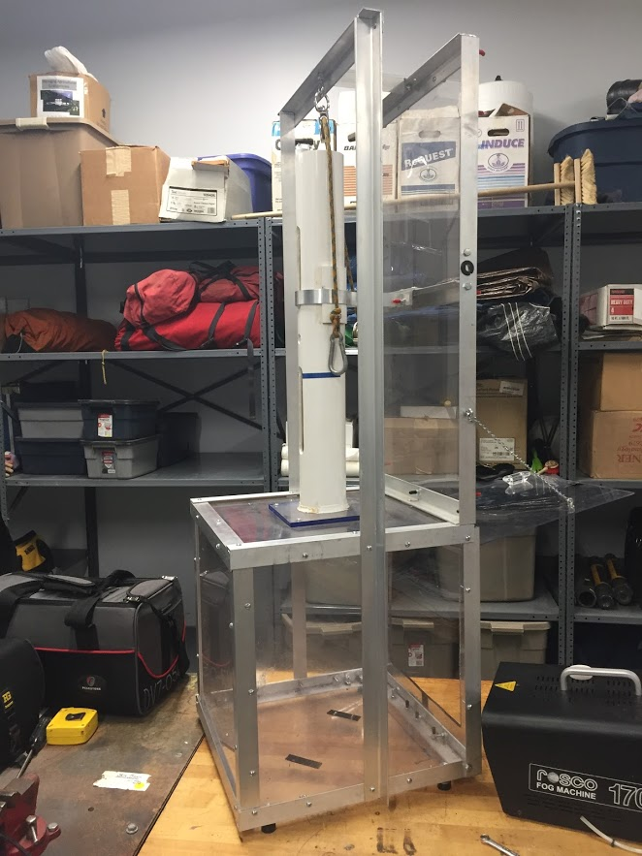
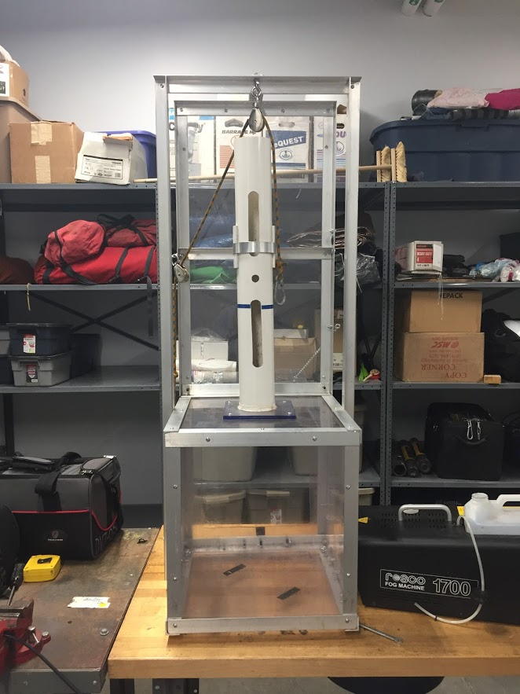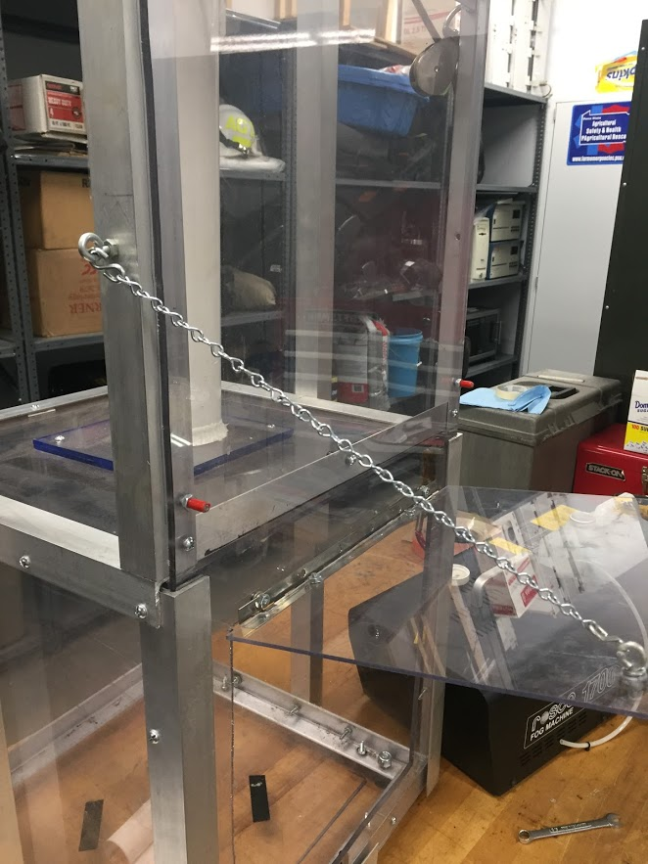

Materials
450” of 1.25” aluminum angle 0.125” (1/8”) wall thickness
36” of 1” wide flat aluminum strap 0.0625” (1/16”) thickness
26” of 3.5” O.D. PVC pipe
12” of piano hinge for door
Pull knob for door
Light chain for door support
S-hooks for door support
Two Pulleys to accommodate rope
3 ft of ½” Rope
#10 machine bolts and nuts
#10 rubber screw protectors
(2) 0.5 inch Eye bolts
(7) 0.118” thick X 48” x 24” Clear Polycarbonate sheets
5.5” of 2” round bar to make a 10 lb. weight to drop through PVC (may substitute material)
Caulk to seal PVC pipe to flange
(4) Rubber chair glides for base

Tools
Drill
Drill bits
Screw driver
Wench
Saw for cutting metal

Cut list
(2) 49” of angle for front upright supports
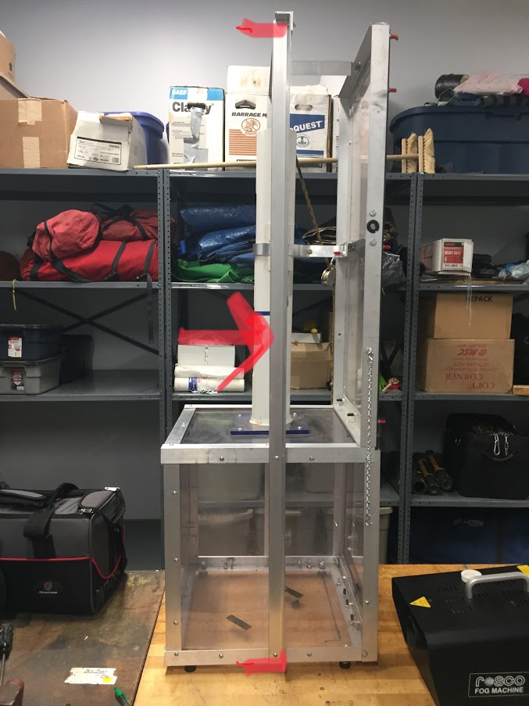

(4) 17.25” of angle for vertical members of lower box section

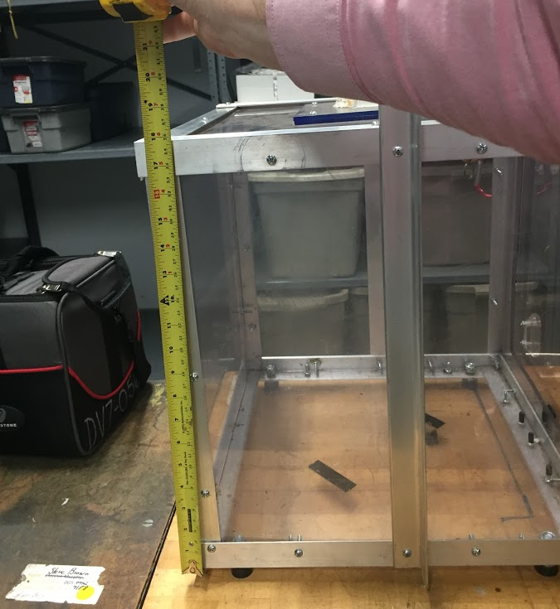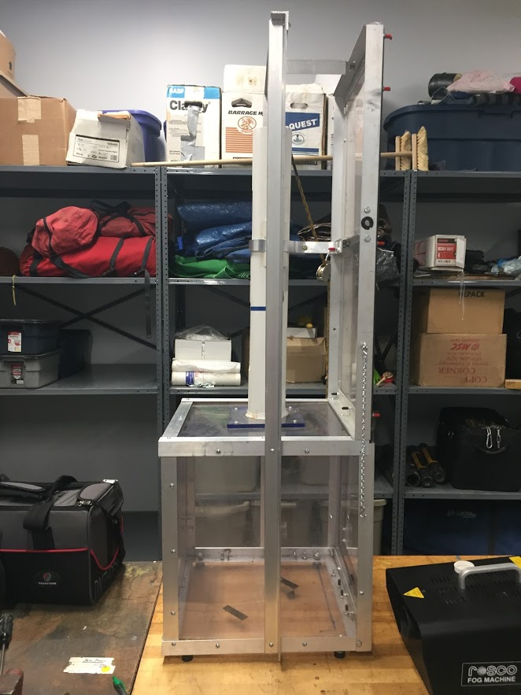

(1) 4” of angle for brace support for lower section
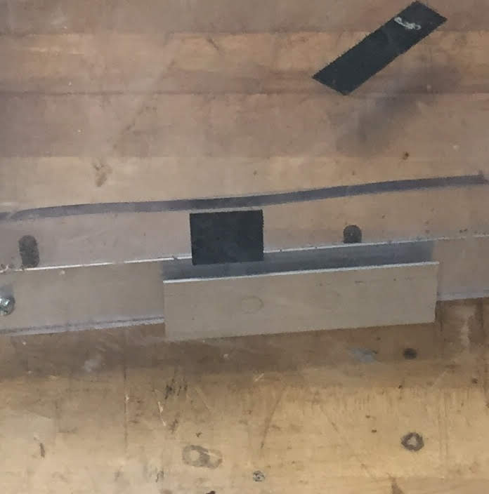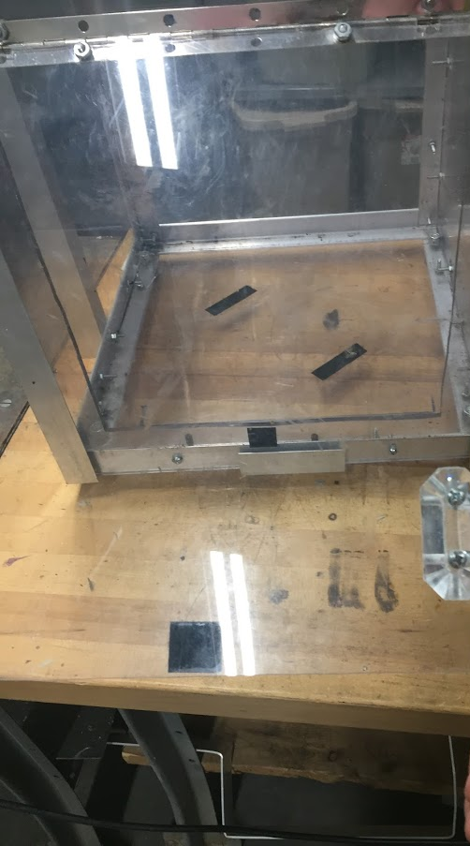

(8) 16.5” of angle for horizontal member of lower box section
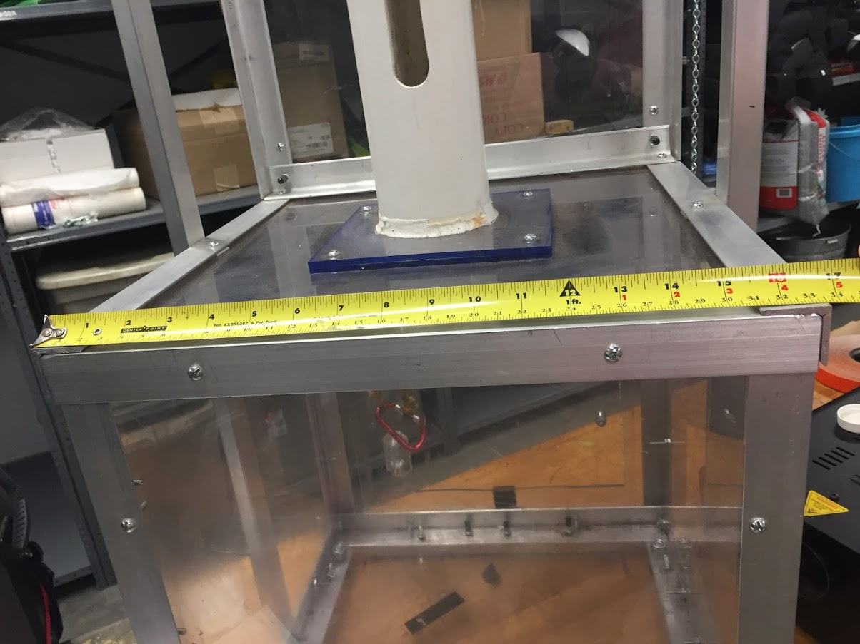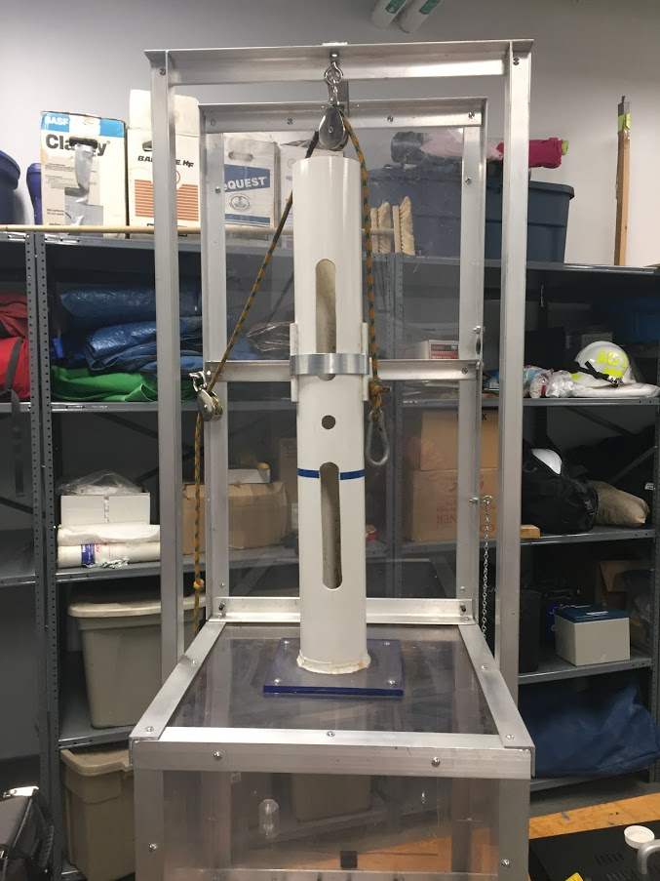

(2) 32” of angle for vertical members for the back of the upper section

(2) 16.5” of angle for cross supports to connect vertical members of upper section

(1) 16.5” of angle for front upper cross member
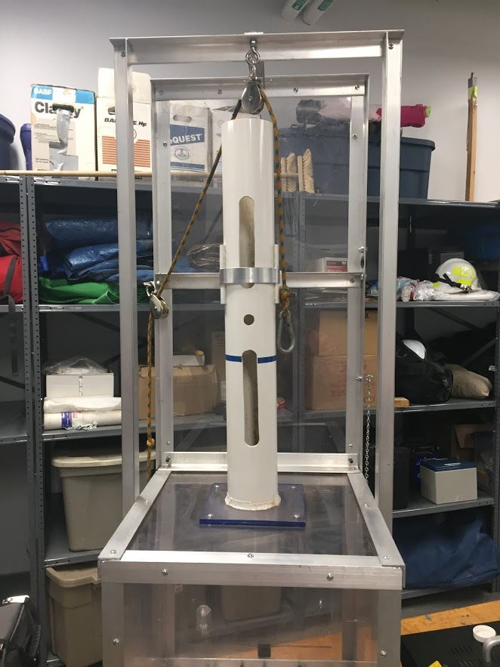

(1) 4” of angle for mounting flat strap to rear cross member.
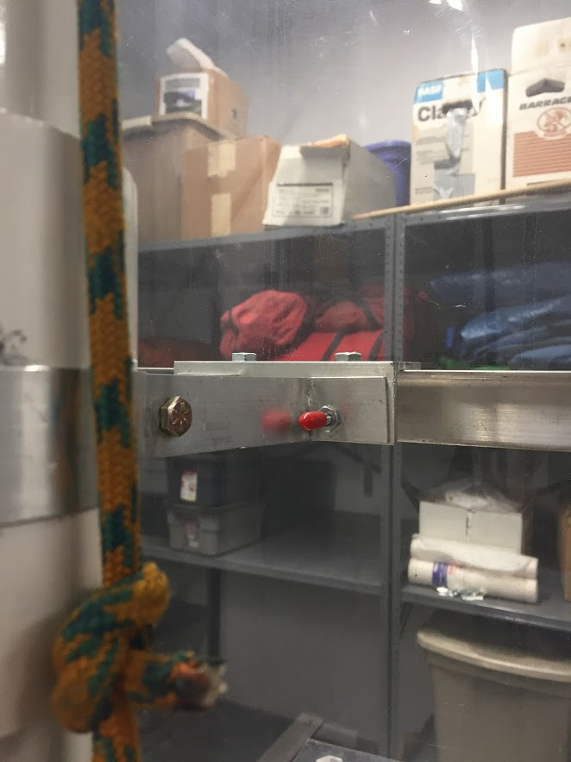Side View

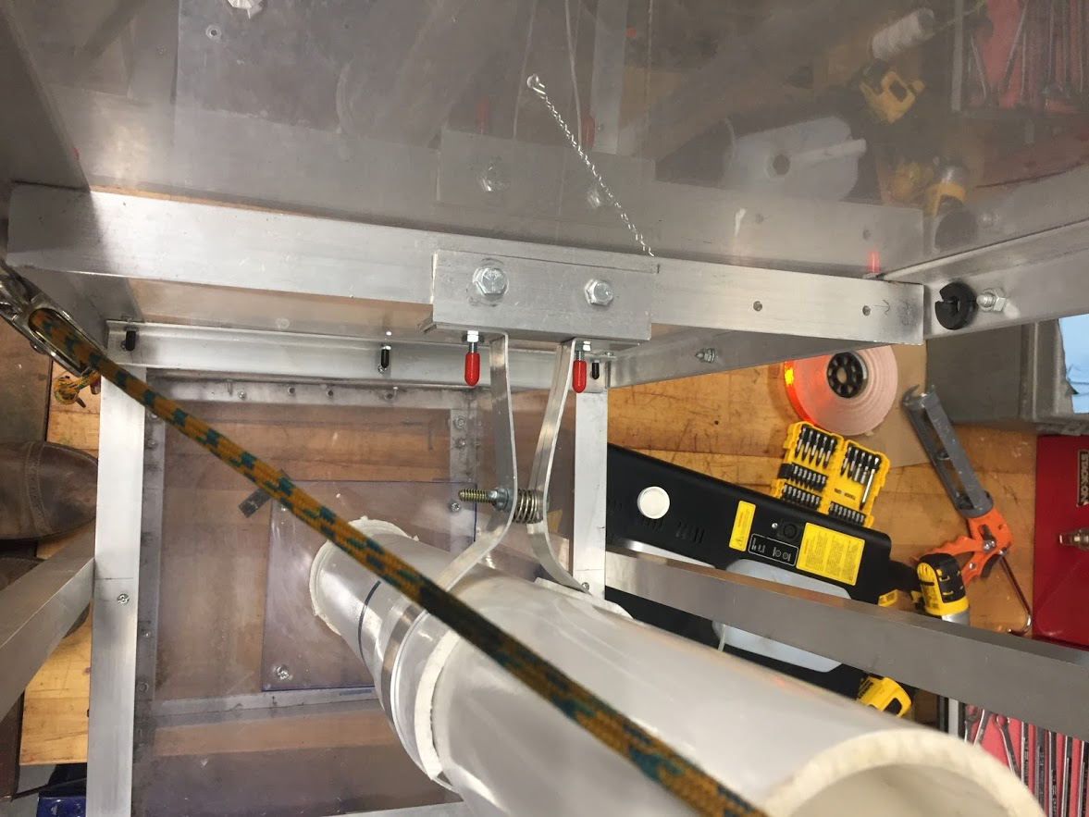 Top view

(1) 21” of flat strap for support around PVC pipe
Top View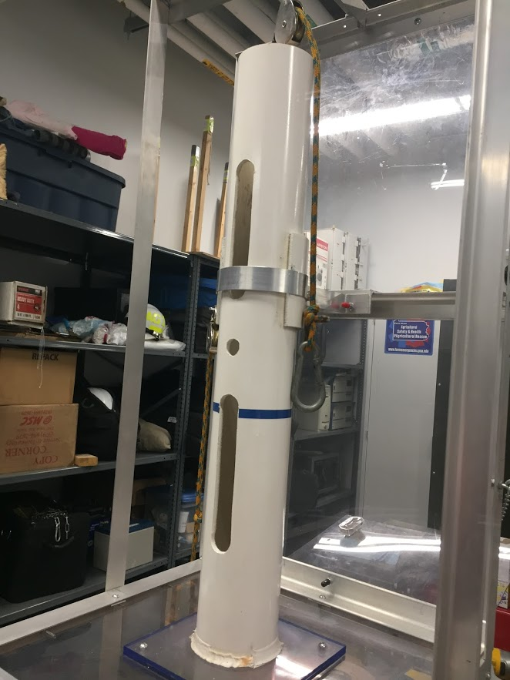Side view

(1) 8” of flat strap for cross support between vertical uprights

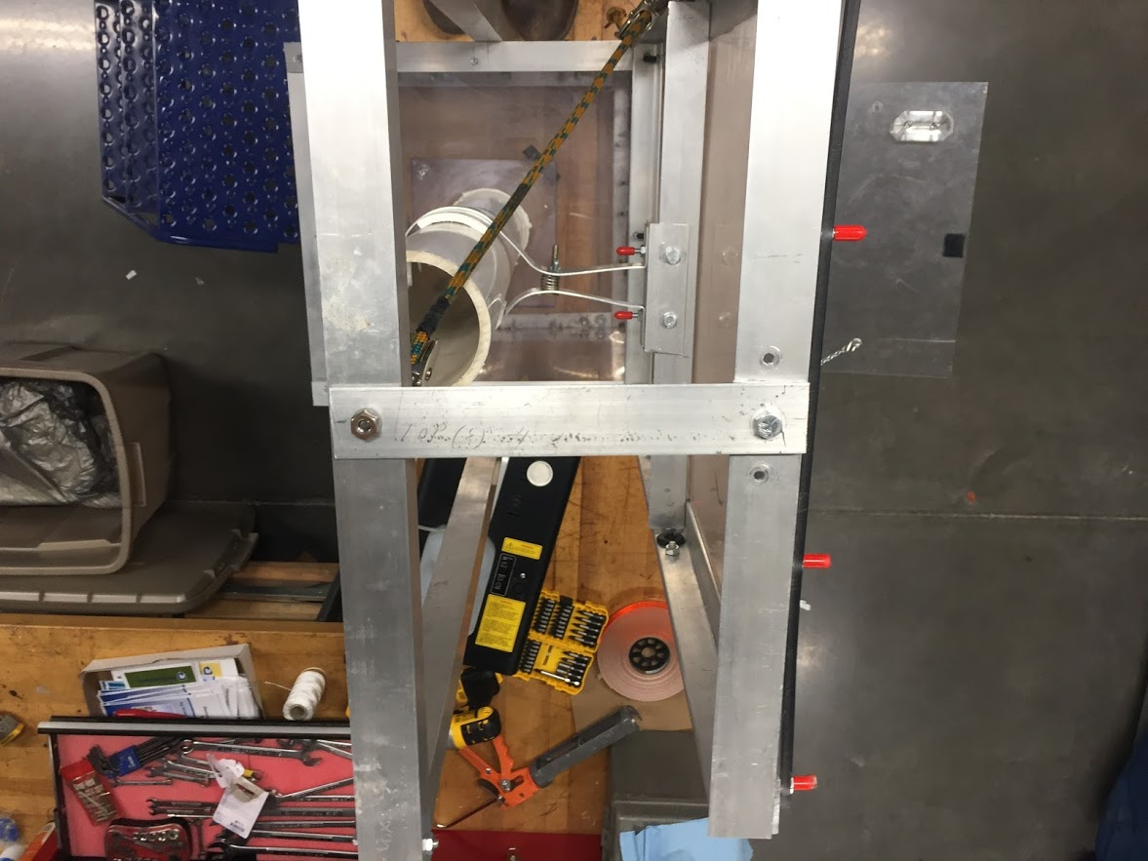

PVC Polycarbonate Flange

Drop Weight
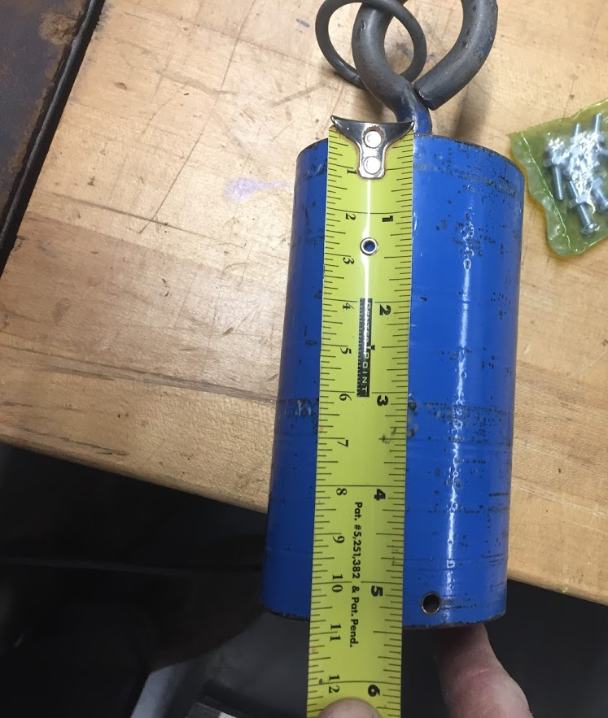
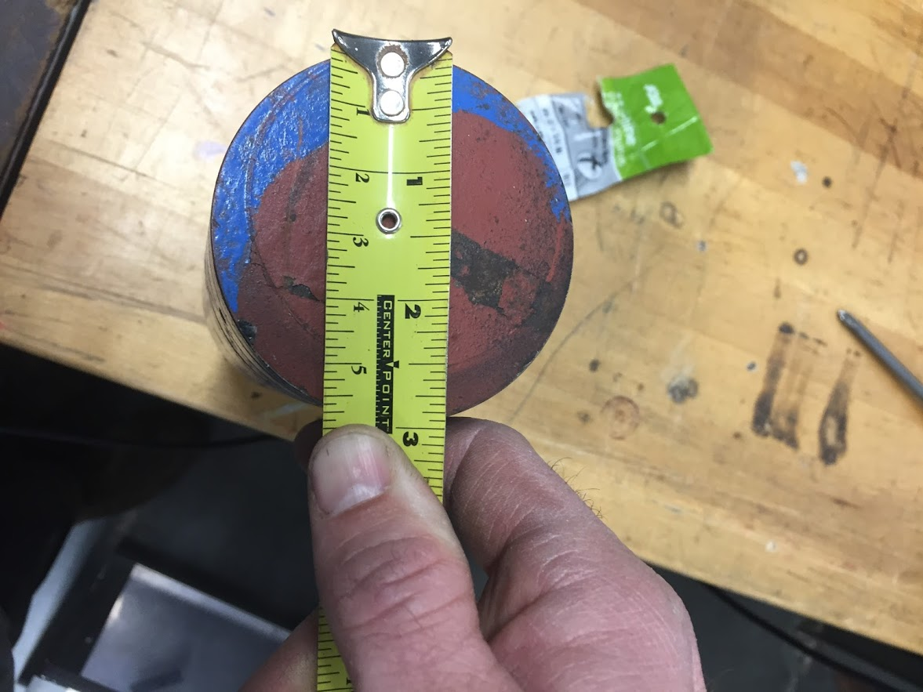
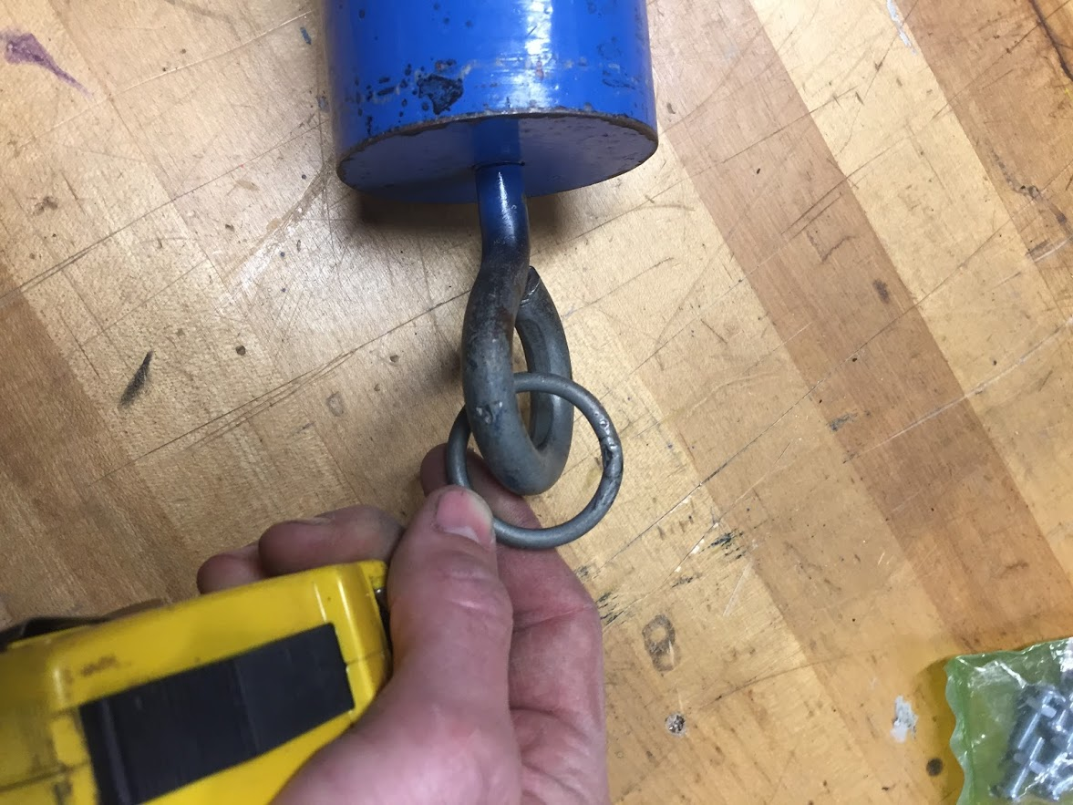
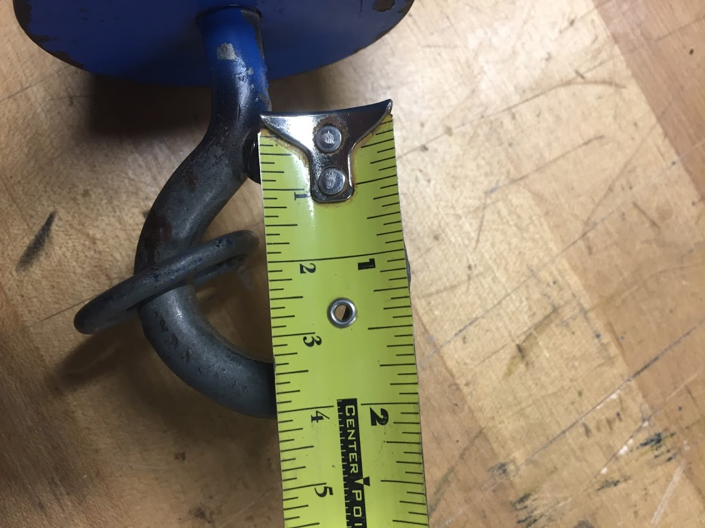

Hole for nail
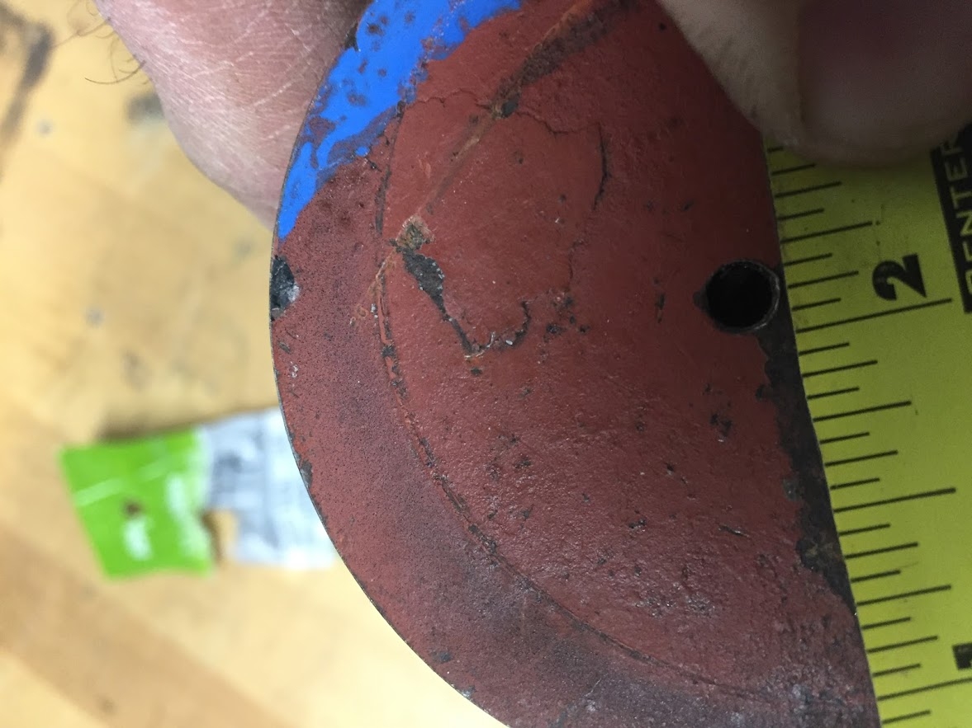
Hole for set screw
